IT24100966

Kaluarachchige P.E.K

Lab 6

Q1)

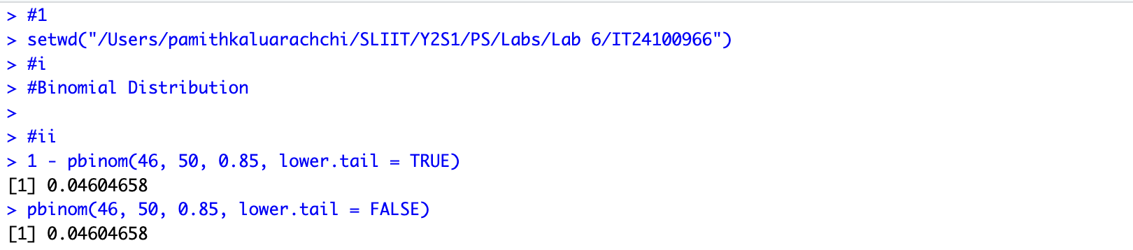

Q2)

